**Experiment No:** 02

**Experiment name:** Elementary signals.

**Objective:**

* To initialize different types of signal.
* To understand the generation of elementary signals using Matlab.

**Discussion:** In this experiment I was learn about various types of elementary signal. Also learned to generate many kinds of signal by receiving information from the user. That was little bit new for me but had some fun to do that. There was no major problem while working and the graphs came very nicely.

clear all

close all

clc;

% t=-pi:0.01:2*pi;

% f=1;

% w=2*pi*f;

%% User Define Input

t=input('Enter the value of Time:');

f=input('Enter the value of Frequency:');

w=2*pi*f;

%% Sinusoidal Wave

y=sin(w*t);

plot(t,y);

xlabel('time');

ylabel('Amplitude');

title('Sinusoidal Wave');

grid on

figure;1

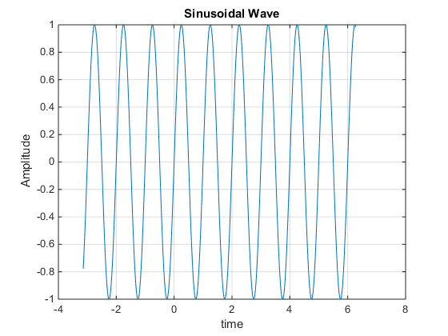

%% Discrete exponential sample wave

t=0:.1:1;

y=exp(-0.4*t);

stem(t,y);

xlabel('time');

ylabel('Amplitude');

title('Discrete exponential sample wave');

figure;2

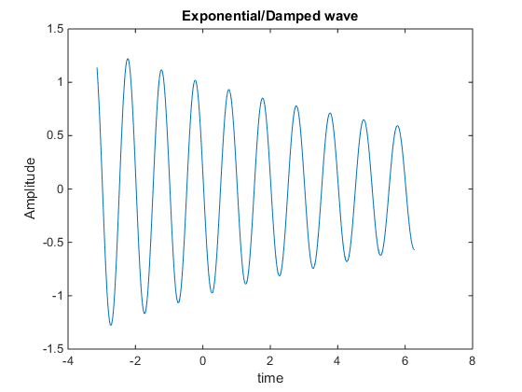

%% Two Exponential Curves

% t=0:.1:3;

% f=100;

% w=2*pi*f;

y1=exp(-0.4*t);

y2=exp(0.4*t);

plot(t,y1,'b',t,y2,'g');

xlabel('time');

ylabel('Amplitude');

title('Exponential Curve');

grid on

figure;3

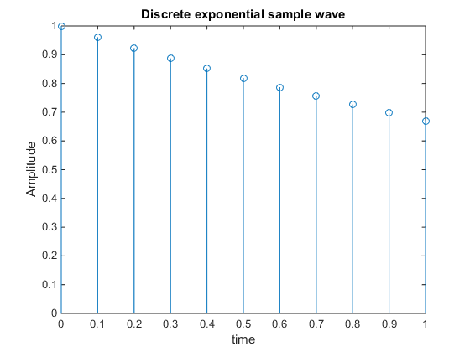

%% Two Exponential Curves including different symbols

y1=exp(-0.9*t);

y2=exp(0.9*t);

plot(t,y1,'b',t,y2,'g>');

xlabel('time');

ylabel('Amplitude');

title('Exponential Curve');

grid on

figure;4

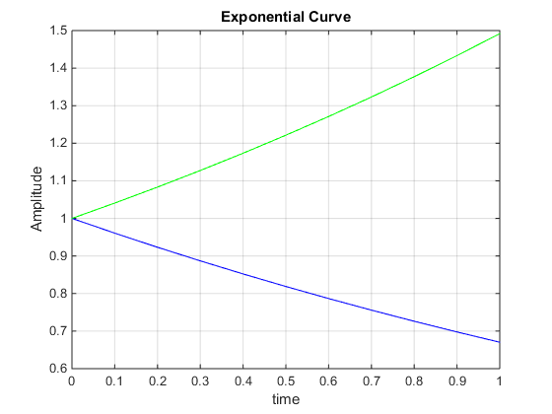

%% Exponential/Damped wave

y=exp(-0.09*t).*sin(w*t+3);

plot(t,y);

xlabel('time');

ylabel('Amplitude');

title('Exponential/Damped wave');

figure;

%% Exponential/Damped wave

y=exp(-0.09*t).*sin(w*t+3);

plot(t,y);

xlabel('time');

ylabel('Amplitude');

title('Exponential/Damped wave');

figure;

%% Negative Exponential Positive Exponential

y1=exp(-0.9*t);

y2=exp(0.9*t);

plot(t,y1,'kd',t,y2,'k>');

xlabel('time');

ylabel('Amplitude');

title('Exponential Curve');

grid on

legend('Negative exp','Positive Exp');

%% Negative Exponential Positive Exponential

y1=exp(-0.9*t);

y2=exp(0.9*t);

plot(t,y1,'kd',t,y2,'k>');

xlabel('time');

ylabel('Amplitude');

title('Exponential Curve');

grid on

legend('Negative exp','Positive Exp');

%% Negative Exponential Positive Exponential

y1=exp(-0.9*t);

y2=exp(0.9*t);

plot(t,y1,'kd',t,y2,'k>');

xlabel('time');

ylabel('Amplitude');

title('Exponential Curve');

grid on

legend('Negative exp','Positive Exp');

figure:5

